PARADISE HOTEL BUSAN  RESERVATION FORM |  | APASL STC 2023 BUSAN  September 21-23, 2023
*Check-In Date: |  |  |  | *Check-Out Date: |  |  | 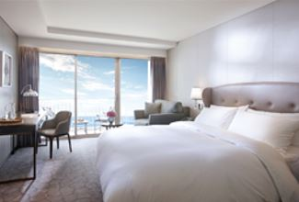  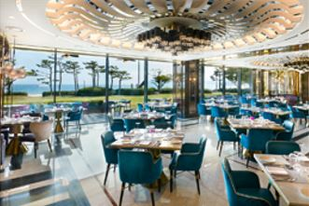  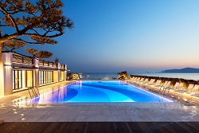
*No. of Persons:
*Name (Family/Given):
*Telephone: |  |  |  | *E-mail:
*PAYMENT INFORMATION (In order to guarantee your reservation, credit card information must be accompanied)
*Credit Card: ☐Other ☐Visa ☐Masters ☐Amex(4digit-number: )
*Credit Card Number:
*Expiry Date(MM/YY): |  |  |  | *Card Holder’s Name:
*SPECIAL ROOM RATES (Room Only) (Unit: Korean Won)
Room Type |  |  | *Monday ~ Thursday |  | *Friday | *Saturday |  | *Sunday
Main Bldg.(본관) | Deluxe City View |  | ☐ \229,900 (Double Bed)  ☐ \229,900 (Twin Beds) |  | Surcharge  +\72,600 | Surcharge  +\169,400 |  | Surcharge  +\36,300
Annex Bldg.(신관) | Deluxe City View |  | ☐ \254,100 (Double Bed)  ☐ \254,100 (Twin Beds)
Annex Bldg.(신관) | Deluxe Ocean View |  | ☐ \290,400 (Double Bed)
Main Bldg.(본관) | Deluxe Ocean Terrace View |  | ☐ \314,600 (Double Bed)  ☐ \314,600 (Twin Beds)
Annex Bldg.(신관) | Deluxe Ocean Terrace View |  | ☐ \338,800 (Double Bed)  ☐ \338,800 (Twin Beds)
* Breakfast Buffet (Main Bldg. 1F. On the Plate, 06:30~10:00): \50,000/Person, * Extra Bed/Bedding: \72,600/Night
* Special Request :
* The above mentioned room reservations may be closed in advance.
* The rates above are non-commissionable, and they are Inclusive of 10% Service Charge and 11% Government Tax.
* The rates above are not inclusive of breakfast.
* Number of guests: 2 Adults / All rooms of the Building are non-smoking areas.
* Check-in time is 3p.m.(15h00) Check-out time is 11:00 a.m.(11h00). Past the mentioned check-out time, the following rates will be applied
(Until 3p.m.(15h00): 50% of the room rate, After 3p.m.(15h00): 100% of the room rate)
* Benefits Included: Outdoor Ocean pool(Swimming pool), Fitness Club, Business Center, Paradise Kids Villages, Wi-Fi
* The Leisure facilities(Ocean Pool, Fitness Club, Sauna, Spa ‘Cimer’) will be closed for maintenance every fourth Wednesday each month.
CANCELLATION POLICY
* Amendaments, Cancellations are availble upon following regulations: Hotel has the right to claim all room charge, which would be deducted from your guaranteed credit card. Cancellation or No-Show after the room reservation is being charged as below:
- From 5days to 3days prior to Arrival date(~18:00): 50% of the Room charge
- From 2days or less prior to Arrival date(Includling No-Show): 100% of the Room chrarge
Please send your reservation form to: res@paradisehotel.co.kr (Tel. +82-51-749-2111~3)

